[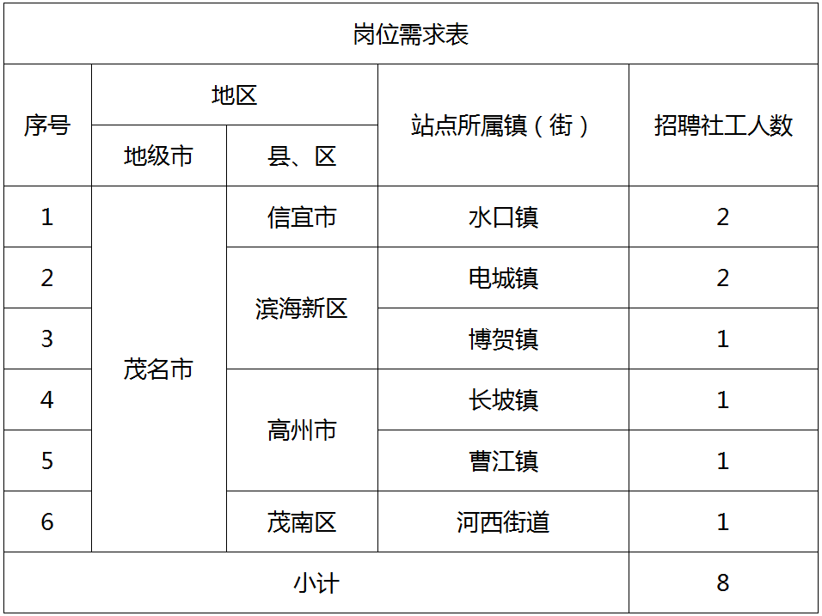](http://www.shuangbai-plan.org/wp-content/uploads/2020/05/20200509035256997.png)