[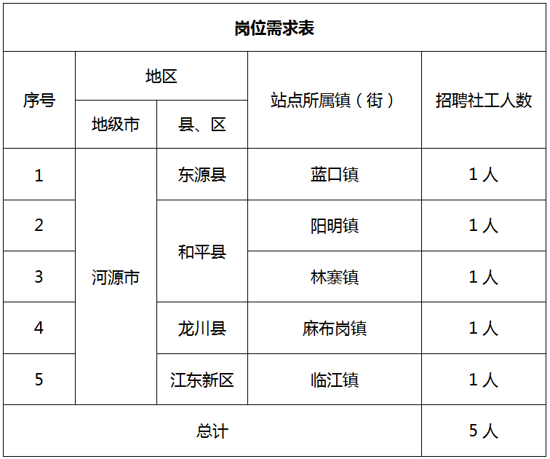](http://www.shuangbai-plan.org/wp-content/uploads/2020/04/2020040905221773.jpg)